***Client server:***

The way a server provides resources and services to one or more clients is described by the client-server model. We have clients (a,b and c ) and it validates user details the same way as peer to peer but in client server the user sends the messages to the server with the receiver name that will receive the message. The connection in client server is between them and the server not between them and each other’s like p2p

***Peer to peer:***

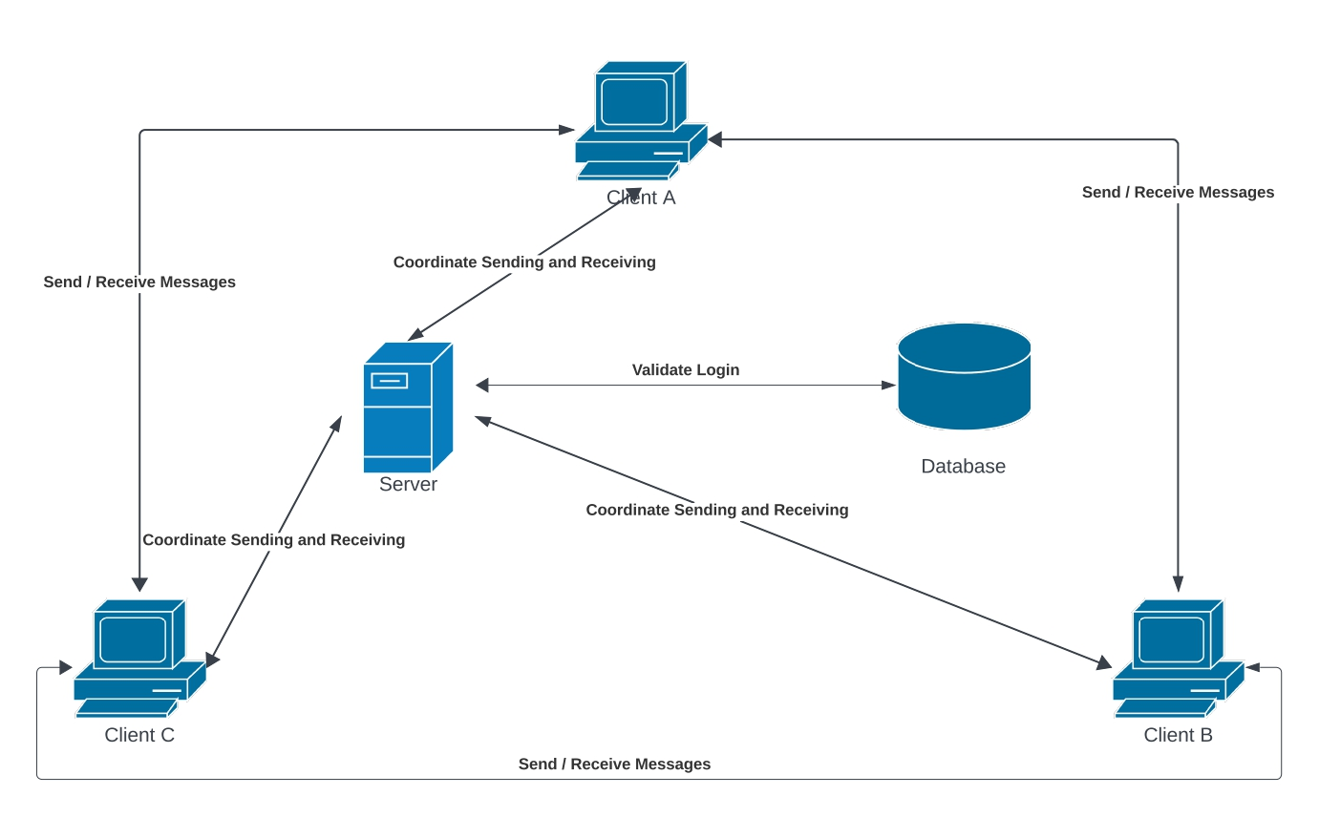

A peer-to-peer (P2P) network is created when two or more PCs are connected and share resources without going through a separate server computer. Clients (a,b and c ) send requests to connect with the server to validate the user details with database then it will send and receive the messages with each other’s and the server can act as a tracker to coordinate the sending and receiving (optional)